Continuous Integration and Continuous Deployment Lab

Experiment – 6

**Name : Harivansh Mathur**

**Roll No : R171218043**

**Create Pipeline using Jenkinsfile**

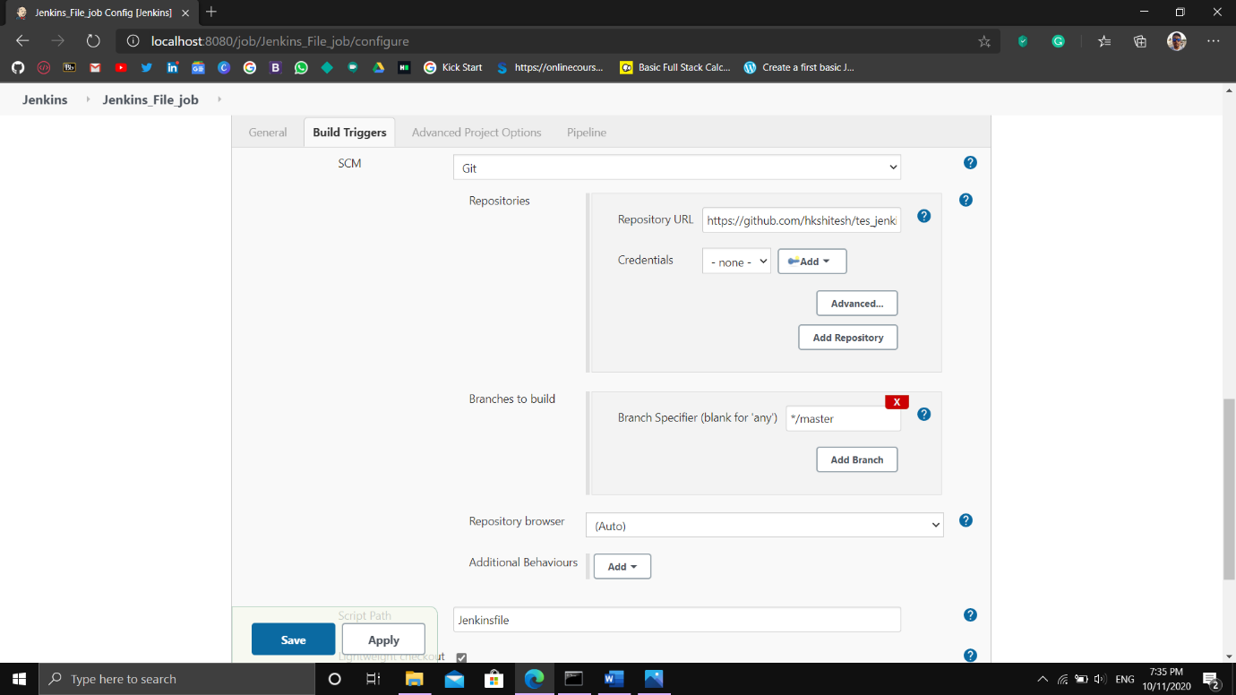

Linking the job on Jenkins to the jenkinsfile stored on GitHub

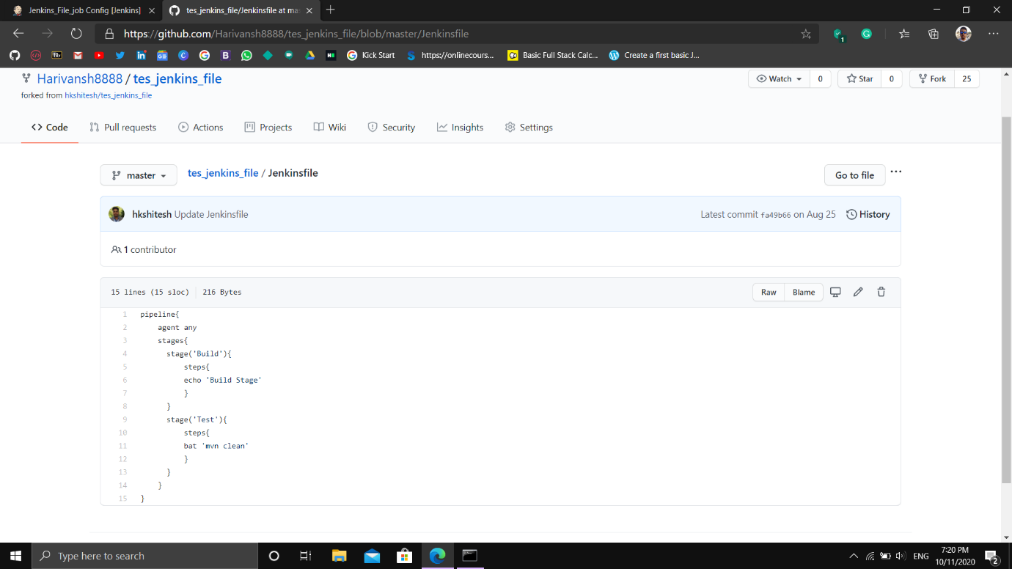

Jenkinsfile

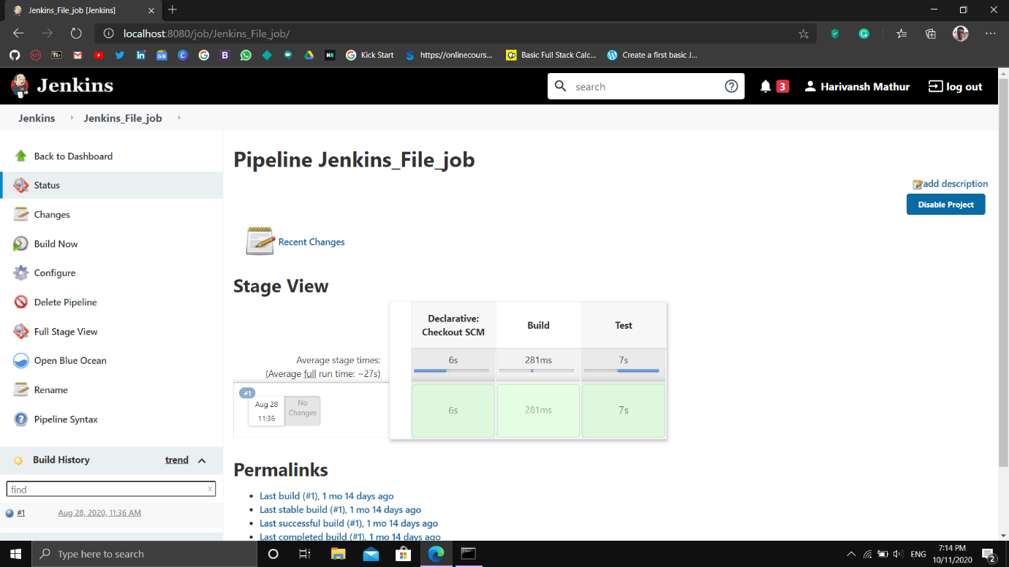

Chart type representation of the pipeline status

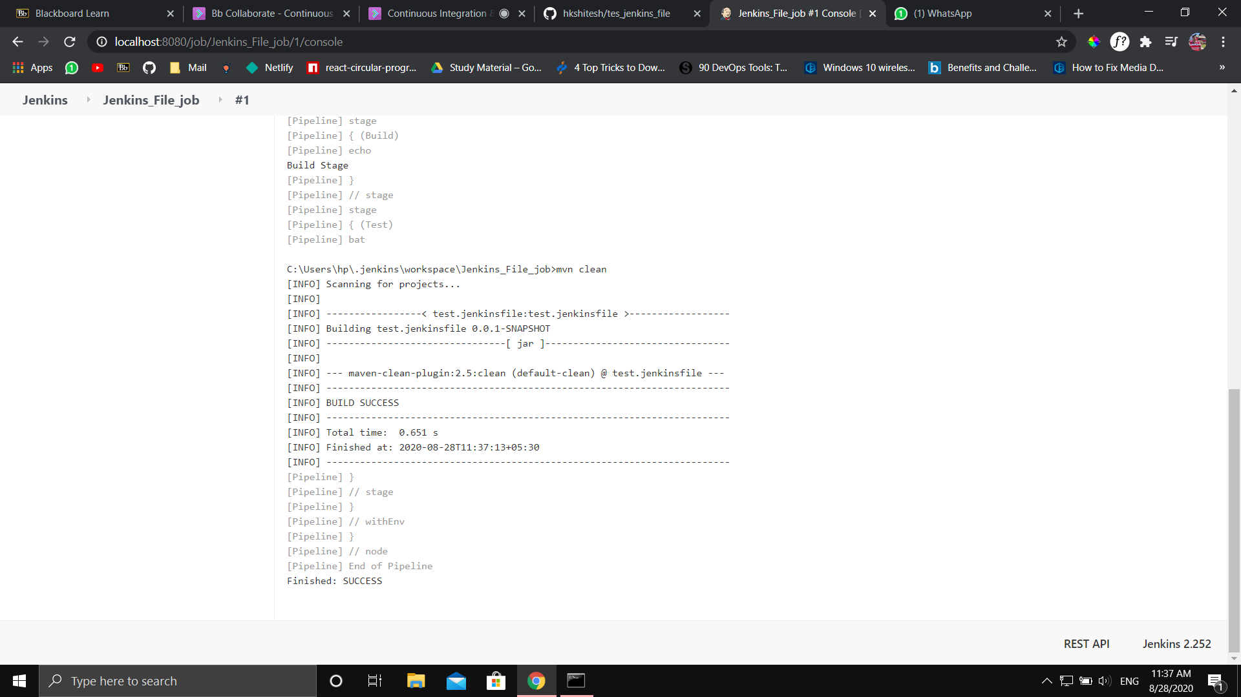

Pipeline Build Success